
Results of a Survey among University Students
Publication Date: 26 June 2012
Fieldwork: 16-22 May 2012

Sample Size: 1500 student in five Palestinian Universities
Kamal Nasser St. # 43, Masayef, Ramallah – Palestine. Phone/Fax number: 02-2950957;
e-mail: award@awrad.org; website: www.awrad.org.

- Introduction
AWRAD is working to empower Palestinian youth across university campuses. AWRAD’s work has focused on the development of research and planning skills among members of the newly-elected student councils. As such, AWRAD carried out a baseline survey in five universities: Birzeit University, Bethlehem University, Hebron University, Al Quds University, and Palestine Polytechnic University. Throughout April and May 2012, these selected universities conducted elections for their student councils. The elections were highly contested and all relevant political groups including Fatah, Hamas, and other independent and leftist groups participated in the process. The survey questioned students on their needs and priorities, voting patterns, and political views. A representative sample of 1500 students was selected, composed of 300 students from each university campus. The results were later weighted to reflect the size of the student population of each campus. The following is an analysis of the basic data of the survey.

- Voting Patterns
- Participation
The survey revealed that the overall voting rate was 78 percent of the eligible students. In contrast, 22 percent of students did not vote. The rate revealed by our survey is consistent with the overall official total rate for all five university campuses. The participation rate was higher among male students (85 percent) than female students (73 percent).
- Reasons for Participating
Students who voted cited the following reasons as (very important):
- Voting is a right and should be exercised (48 percent);
- Student councils are important in defending student rights (33 percent);
- Voting is an expression of political views (10 percent);
- Preventing a list from winning (6 percent);
- The leadership of a party encouraged members to vote (1 percent).

- Reasons for Not Participating
Students who refrained from voting cited the following reasons as (very important):
- Wanted to participate but were busy (25 percent);
- Not convinced by the agenda of any of the available lists (25 percent);
- Student councils are of no real utility to students (21 percent);
- Lists do not place enough emphasis on student issues and needs (13 percent);
- Campaign negativity (5 percent);
- Support for a list that did not run (3 percent).

The following graphs illustrate the results:

Graph (1): Reasons for Participating
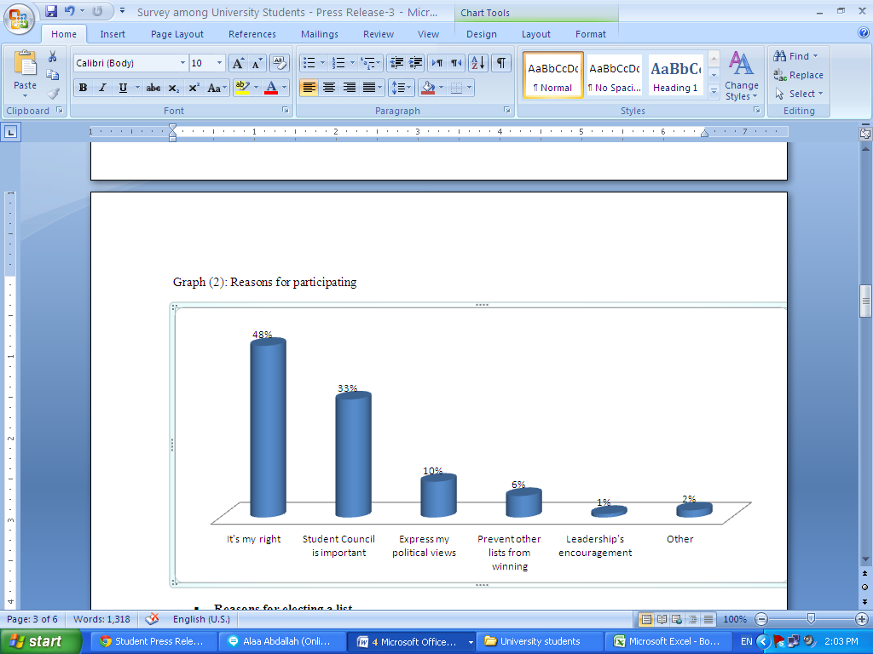
Graph (2): Reasons for not participating

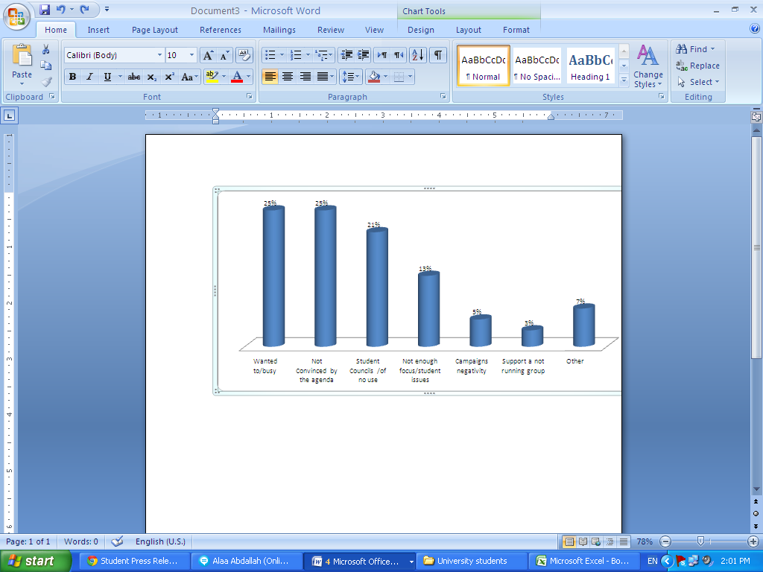

- Reasons for Electing a List
Students were asked about their motivation when selecting which list to vote for. In general, the results show that students were more motivated by student-related issues on campuses than partisan politics and political issues at the national level. The following factors were deemed as (very important):
- The ability of the list to defend student demands in the face of the university administration (51 percent);
- The list’s fulfillment of student demands and needs (49 percent);
- The equal attention for male and female students by the list (47 percent);
- Provision of material and in-kind assistance to students (43 percent);
- Political affiliation and membership in a party (41 percent);
- The ethics and overall conduct of the members of a list (38 percent);
- The political platform of a list (38 percent);
- The political performance of the Palestinian Authority (PA) in the West Bank (21 percent);
- Regional representation of the members of the list (21 percent);
- Religiosity of the members of a list (20 percent);
- Political arrests and intimidation of list members by the PA (20 percent);
- The performance of the PA in economic development and job creation (19 percent);
- The overall performance of the government in Gaza (18 percent);
- The outcome of Arab revolutions (14 percent);
- Receiving a direct payment/benefit for the vote by a list (5 percent).

- Satisfaction with the Results
The students were questioned about their satisfaction of the council elections, and the results show that:
- 47 percent are satisfied with the results on their campuses;
- 27 percent are (somewhat satisfied);
- In contrast, 25 percent are not satisfied.

The graph below illustrates these results:

Graph (3): Are you satisfied with the results of this year’s student council elections in your university?
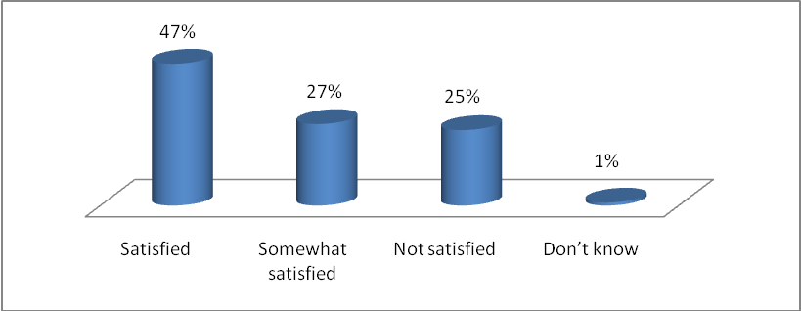
Regarding the fairness of the elections, students expressed the following views:
- 50 percent believe that the elections were fair;
- 28 percent believe that they were fair to some extent;
- 16 percent of the students disagree and believe that the elections were unfair.

The following graph demonstrates these results:

Graph (4): Do you believe that the student council election was…?
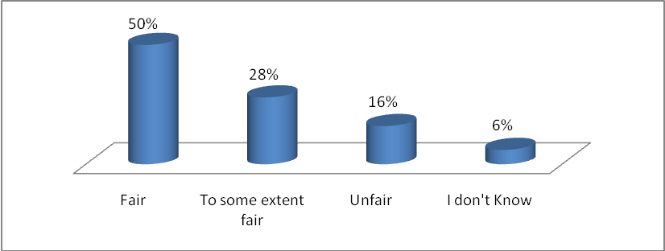

- Election Campaigns
Students were asked about the effectiveness of a number of campaign tools/methods in convincing them to vote for a list. The following tools/methods were considered as (very important):
- The debate allowing representatives of lists to present their platforms (34 percent);
- The overall campaign activities on campus (30 percent);
- Face-to-face meetings (29 percent);
- Public meetings and rallies organized by the list (20 percent);
- Publications and campaign materials distributed by the list (20 percent);
- Influence of list/party members in my community (13 percent);
- Visits by campaigners to my residence/dorm (11 percent);
- Influence of my class/college mates (11 percent);
- Electronic messages – SMS and Internet (11 percent);
- Influence of roommates (9 percent).

- Political Views
As much as 64 percent of the students believe that the results of the elections reflect the political landscape in the West Bank. 34 percent of respondents disagree.
Students were also questioned about their views of political institutions and actors:
- West Bank and Gaza Governments: Students were critical of both governments:
- Only 22 percent positively evaluated the performance of the West Bank government. 42 percent evaluated its performance as fair. In contrast, 31 percent gave a negative evaluation.
- Regarding the government in Gaza, 17 percent gave a positive evaluation, while 37 percent gave it a fair evaluation. The negative evaluation of the Gaza government was equal to that of the West Bank government (at 31 percent).
- M. Abbas and K. Mashaal: Students were split in their evaluation of Abbas and Mashaal:
- 28 percent positively evaluated the overall performance of President Abbas, while 36 percent evaluated it as fair. In contrast, 28 percent negatively evaluated his performance. 8 percent did not know.
- 19 percent positively evaluated the overall performance of Hamas leader Mashaal, while 36 percent evaluated it as fair. In contrast, 26 percent negatively evaluated his performance. As much as 19 percent did not know.

- Needs &Priorities
Respondents emphasized student issues in their expectations of the recently-elected councils. Additionally, students expressed interest in national issues.Students were asked about the priorities they believe the new councils should emphasize. The following issues were cited as (most important):
- Reducing fees and tuition (78 percent);
- Providing material and in-kind assistance to needy students (74 percent);
- Organizing activities related to national political issues (61 percent);
- Reducing obstacles when selecting majors (55 percent);
- Promoting respectful relations between students and faculty (49 percent);
- Promoting social cohesion among students on campus (46 percent);
- Working to improve the quality of education (41 percent);
- Helping new graduates find employment opportunities (39 percent);
- Helping enrolled students find employment opportunities (27 percent);
- Promoting volunteer work and activities (25 percent);
- Organizing cultural activities (19 percent);
- Organizing sports activities (16 percent).

Hamas did not participate in one of these elections (Bethlehem University).

